

|  |  |  |
| --- | --- | --- |
| **Tata AIA Life Insurance Company Ltd** | | |
|  | **Investigating Agency Details: X-PERT Investigation Field Investigator Name: ANKUSH KAHAR** | **Date of Visit: 27/11/2021 Date of Report: 27/11/2021** |
|  | **LA Name & Contract No:** **SANTOSH GUPTA**  **PROPOSAL N0.- C184470310** |  |
| **Scenario 1: Life Assured Met or Deceased** | | |
| **Section 1** | **If LA is Alive and in Good Health (Please answer the below)** |  |
| **1.1** | Financial Status of Life Assured (Please mention your observation basis life style etc) | MIDDLE CLASS |
| **1.2** | Life Assured's Physical apperance checked | NO |
| **1.3** | Neighbour Check done (Neighbour check done to verify Health Status of LA) | YES(ANKIT GUPTA,RAJESH GUPTA & AMIT MISHRA) |
| **1.5** | Photographs collected of LA/House (Proof of visit required) | YES |
|  | Remark/ Comments:  HEALTH-LA NOT MET-NA OCCUPATION-SELF EMPLOYED EDUCATION-GRADUATION(B.COM) | WE VISITED AT THE ADDRESS.FOUND ADDRESS IS CORRECT.AT THE ADDRESS WE MET LA's BROTHER(SUNIL GUPTA) AND HE CONFIRMED THAT THE HOUSE IS PARENTS OWNED AND LA HAS BEEN LIVING HERE BY BIRTH.IN THE FAMILY THERE ARE 6 MEMBERS AND 2 EARNING MEMBERS.LA IS RUNNING A GROCERY SHOP SINCE 10 YEARS.HIS ANNUAL INCOME IS APPROXIMATELY 2 LAKHS.WE CHECKED WITH SOME OF HIS NEIGHBOURS(ANKIT GUPTA,RAJESH GUPTA & AMIT MISHRA).NO ADVERSE REPORT FOUND. |
| **Section 4** | **Additional Findings (basis information gathered from Life assured, family, vicinity survey)** |  |
| **1** | Whether LA is Smoker/Non Smoker | NON SMOKER |
| **2** | Whether LA is Self Employed/Salaried | SELF EMPLOYED |
| **3** | LA photographs has been taken | NO-LA NOT MET |
| **4** | LA photographs has not been taken | NA |
|  | | |

**PHOTOGRAPHS**

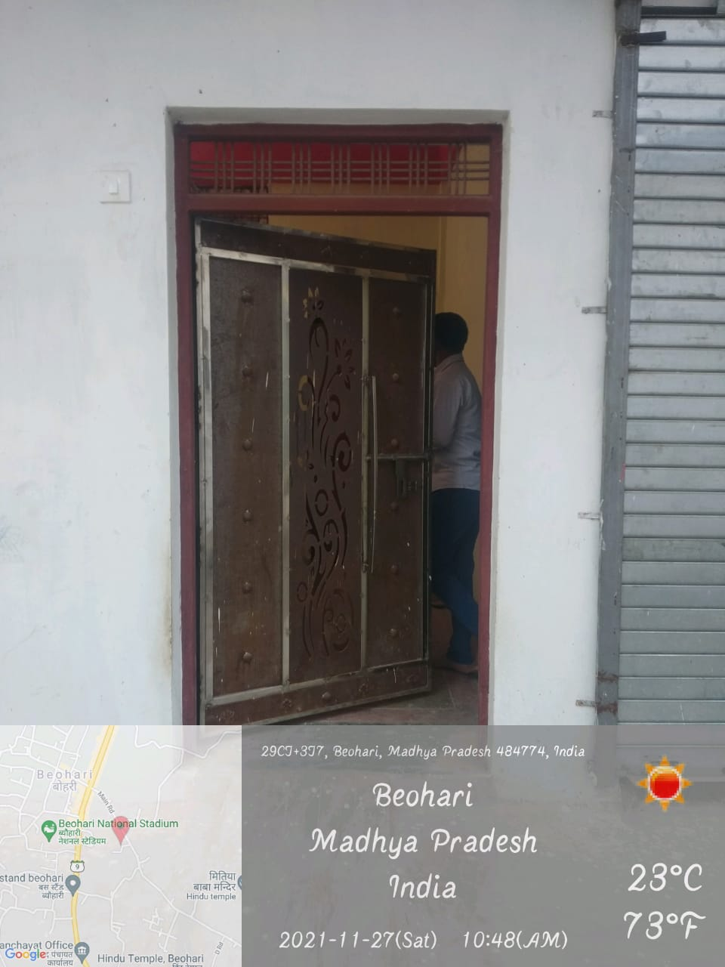 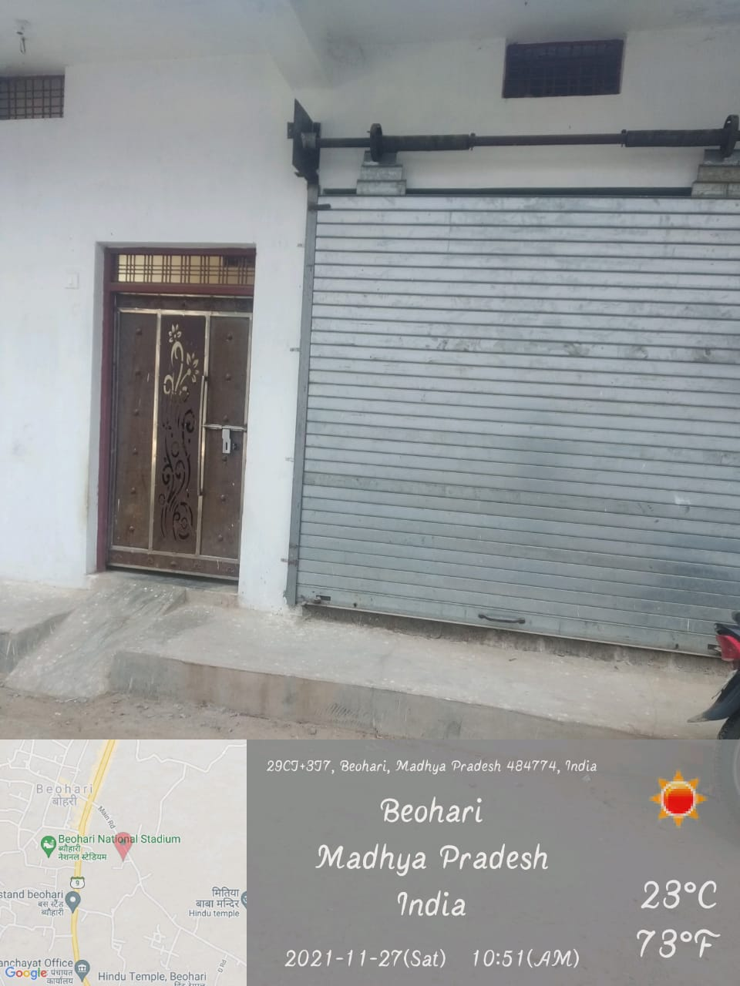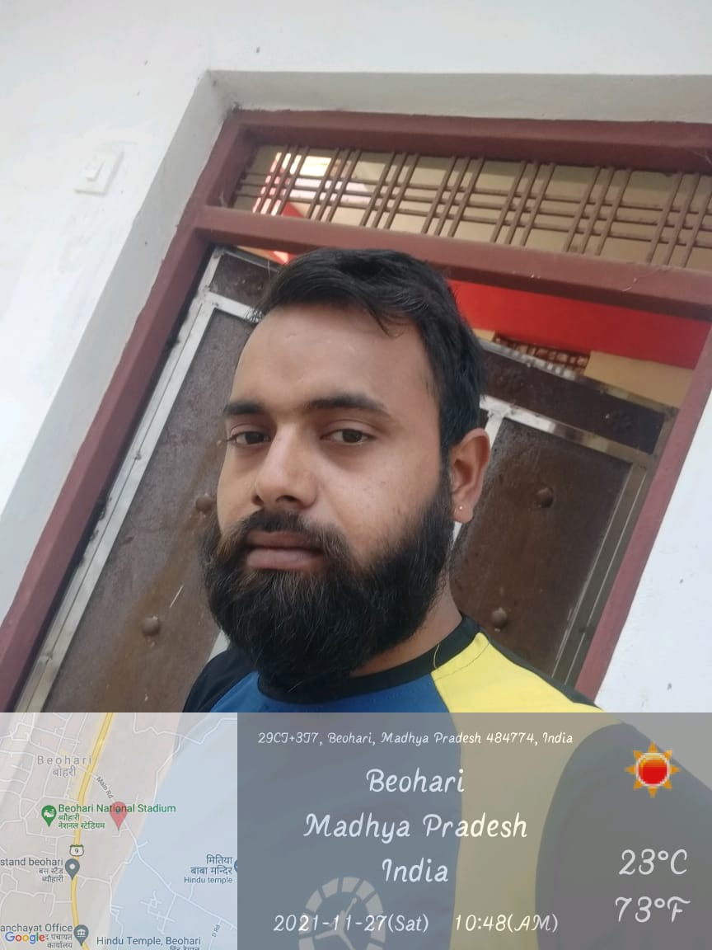

**AGENCY SEAL AND STAMP**